**NCIA and NCA Sign Landmark MoU to Promote Alternative Dispute Resolution in the Construction Sector**

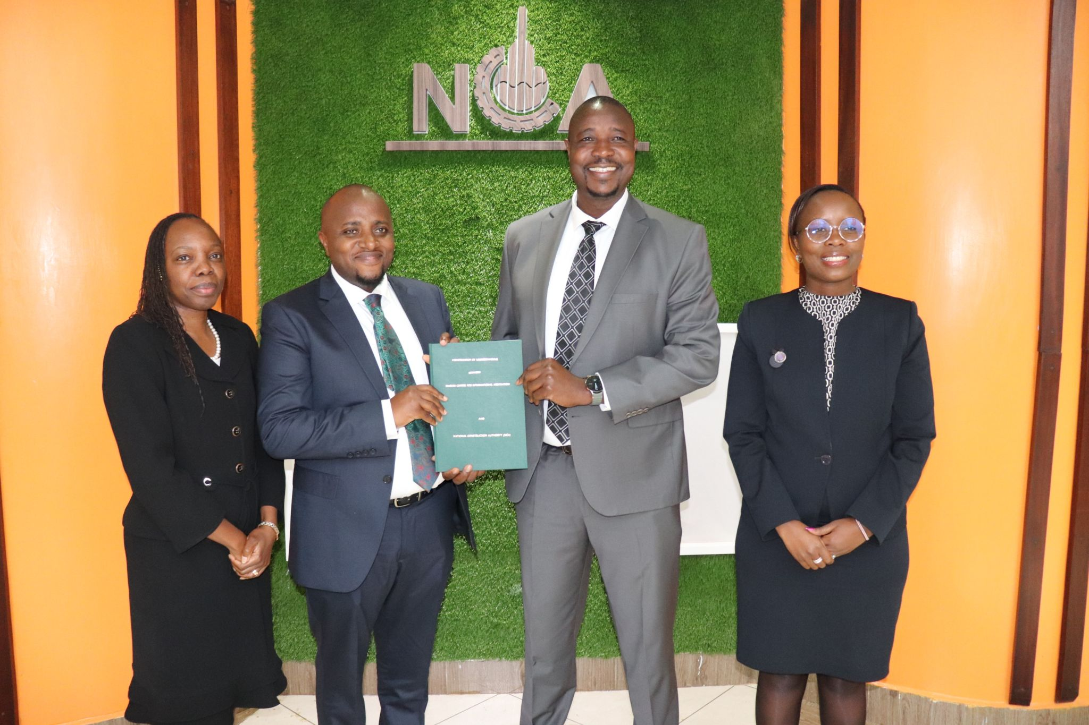

**Nairobi, July 25, 2025** – The Nairobi Centre for International Arbitration (NCIA) and the National Construction Authority (NCA) have entered into a strategic partnership through the signing of a Memorandum of Understanding (MoU) aimed at strengthening the use of Alternative Dispute Resolution (ADR) mechanisms in Kenya’s construction industry.

The MoU was signed at the NCA Headquarters in Upper Hill, Nairobi, in a ceremony attended by senior leadership from both institutions, including Eng. Maurice Akech, MBS (Executive Director, NCA), Dr. Henry K. Murigi, PhD (Registrar/CEO, NCIA), Ms. Jacqueline Oyuyo Githinji, C.Arb, FCIArb (Chairperson, NCIA Board), and Ms. Mercy Okiro, FCIArb (Chairperson, NCA Board).

**Key areas of collaboration under the MoU include:**

* Joint research on the nature, value, and impact of disputes in the construction sector.
* Training and sensitization of contractors, site supervisors, and other stakeholders on ADR methods.
* Capacity enhancement and training for the Boards and staff of NCIA and NCA.
* Joint hosting of information-sharing platforms on construction-related dispute resolution.
* Public awareness, participation, and support for the proposed Construction Adjudication Bill.

Speaking at the signing, Dr. Murigi emphasized the importance of the MoU in strengthening NCIA’s role as a center of excellence for arbitration and mediation in the region. Eng. Akech noted that the collaboration will help address persistent disputes that slow down projects and inflate costs in the construction sector.

The partnership reflects a shared commitment to advancing timely, fair, and cost-effective resolution of disputes, supporting Kenya’s economic growth and the delivery of sustainable infrastructure.

